|  |
| --- |
|  |
| User Manual |
| Simply Car and Van Hire |
|  |
| DANAYAL IFTIKHAR |
| **5/27/2014** |

|  |
| --- |
|  |

Contents

Installation Requirements and Guide 2

installation 2

Using the application 0

Login 0

Possible Error Messages 1

Admin Screen 2

Possible Error Messages 2

Booking a vehicle 3

Possible Error Messages 4

# Installation Requirements and Guide

To install the Simply Car & Van Hire application you will need the following system requirements:

* Windows based system, Vista or later
* 1.6 GHz or faster processor
* 1024 MB RAM
* DirectX 9 capable video card running at 1024 x 768 or higher display resolution
* 3 GB of available hard-disk space
* CD/DVD drive

## installation

1. Insert the application CD into your CD/DVD drive
2. When the autorun dialog appears on screen select “Open folder to view files.”

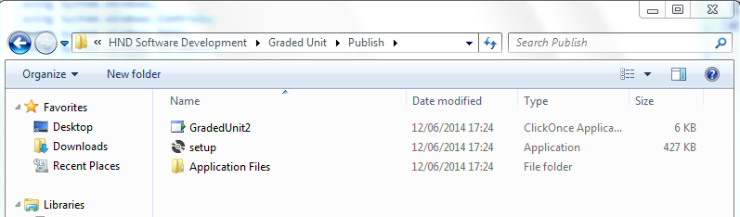

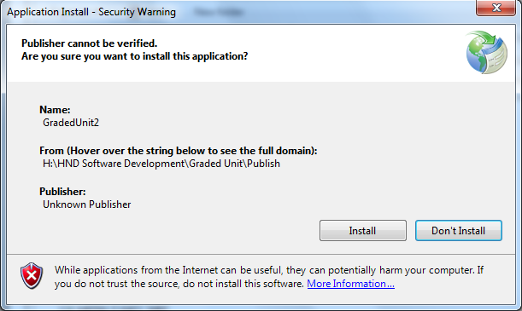

1. Double click the setup file and click on Install.

# Using the application

## Login

1. Login using correct details:

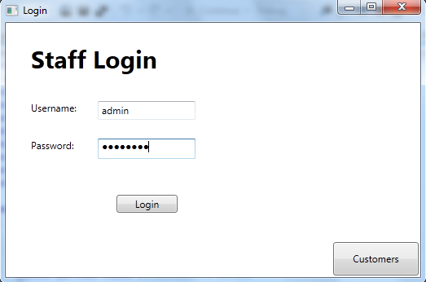

Login with admin details and following screen appears:

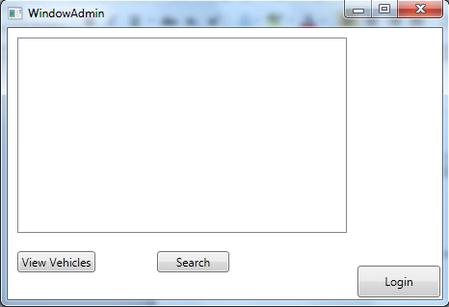

Click “Customers” button and the application will navigate to the following window:

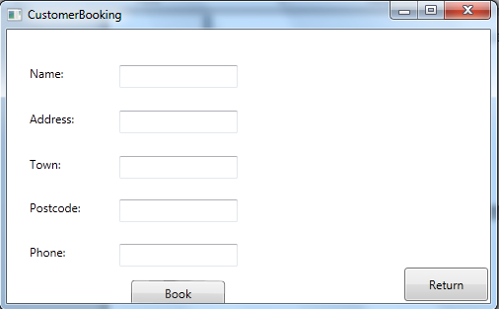

### Possible Error Messages

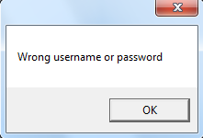

## Admin Screen

-Click the “View Vehicles” button to display the available vehicles and their amount in the listbox

-Click the “Search” button to navigate to a search window to look for bookings already made by a customer



### Possible Error Messages

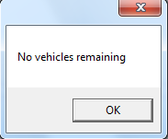

## Booking a vehicle

1. While on the login screen, click the “Customer Booking” button



1. The following screen should appear – enter the first name, last name address, town, postcode and phone number of the customer:



3. Click “Book”

1. Another window should appear asking you which vehicle you would like to book:

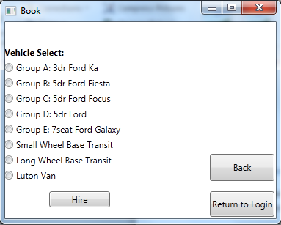

1. Click the option you would like to hire out then click “Hire”

### Possible Error Messages

